**Performance Testing Documentation**

**Tool used for Performance Testing**

* HP Virtual User Generator (VuGen) 11.52 with ALM Addin. HP VuGen also known as HP Load Runner helps us to record the journey/actions of users’ journey for which we are going to calculate response time of the application under any desired data base volume and user load.
  + HP VuGen 11.52 can be installed locally by installing HP VuGen 11.50 and install the below listed patches in same order to get VuGen 11.52
    - LRVUG_00033
    - LRVUG_00044
    - LRVUG_00048
* ALM Addin for VuGen is required to connect to HP ALM for uploading VuGen scripts
* HP Analysis 11.50 is a result collation tool which helps us to know the response time/maximum time for a particular user action during the testing time.
* HP Analysis tool will also provide other values like hits/sec, throughput etc.
* While installing VuGen please note that controller should not be installed.

Type of performance testing

* Load Testing: The term Load refers to the volume of data present in tables.
* Stress Testing: The term Stress refers to the number of users used for testing.

Below are stages we need to follow in order test the performance of the application

* Record a script for single user/journey and validate whether all the required user action is captured
* Once the recording for single user is completed replay the script to check whether all the required user journey is captured or not
* Once the recording is done correctly, fine tune the script and make parameterization for the required input parameters that are needed for the testing.
* After parameterization is done we have to find the dynamic parameters and correlate them.
* Correlation for any given parameter can be done by 2 ways
  + Automatic Correlation
  + Manual Correlation
* Once all the above stages are done we have to validate script by running it locally for the below scenarios
  + Single user Single Iteration
  + Single user multiple Iteration
  + Multiple user Single Iteration

**How to create a script using VuGen**

* Open **VuGen** and click on **File** tab in Menu and select **New Script and Solution**

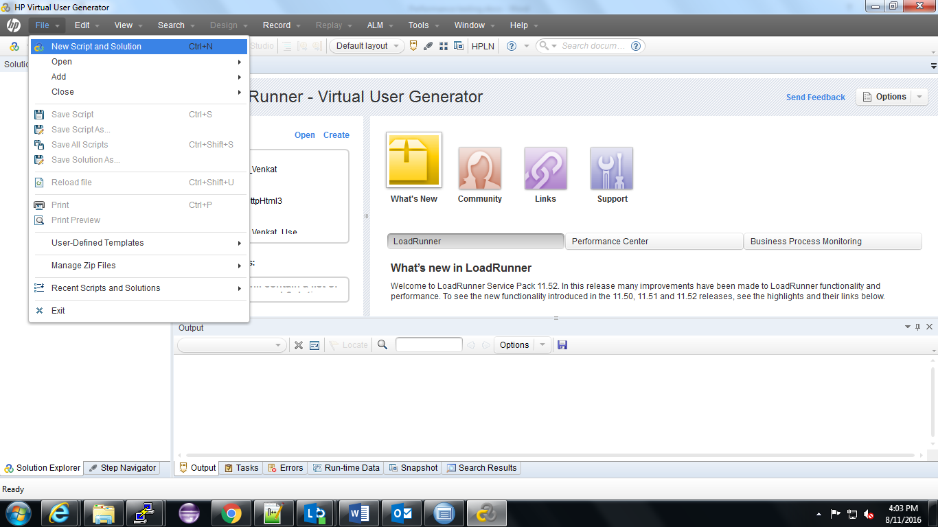

* After clicking on New Script and Solution a dialog box open where user has to select the application protocol and gave name of the script and click on **Create** button

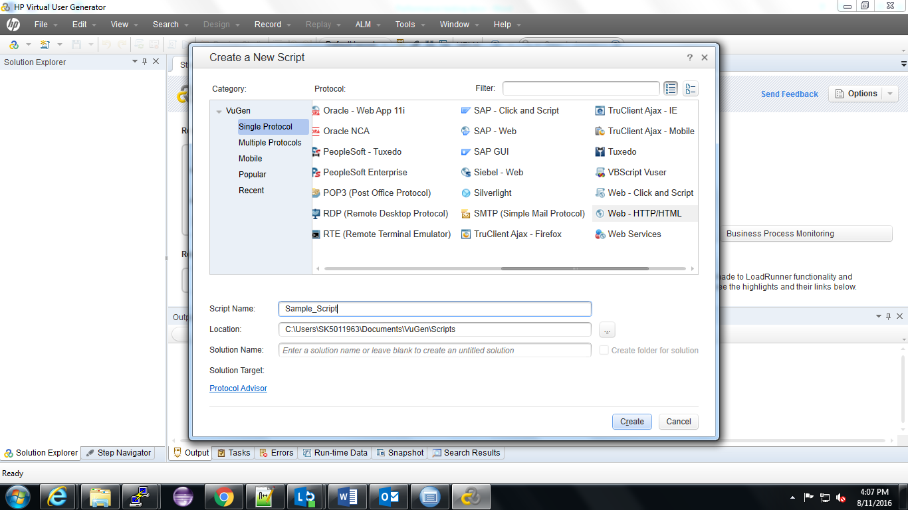

* Upon clicking on the **Create** button the below screen is displayed

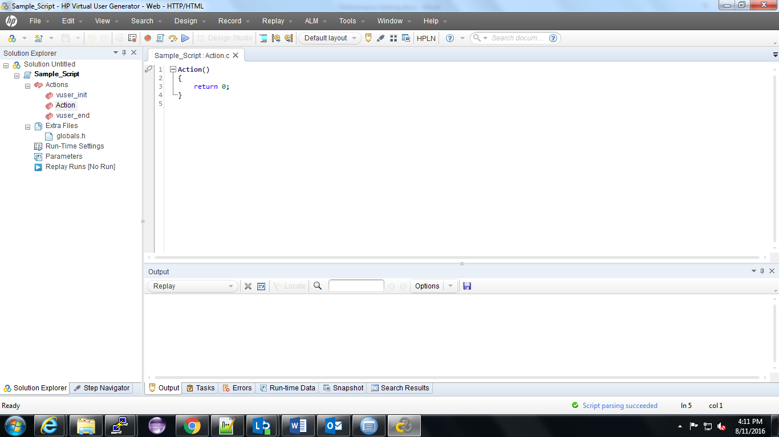

If the user doesn’t know what is the protocol to be used for testing the application user can use the Protocol Advisor option in the create screen to know which protocol to be used



On clicking the Protocol Advisor a dialog box appears where the user has to choose the type of application which we are going to test, browser in which we are going to open the application and URL address of the web application and click **Start** analyzing

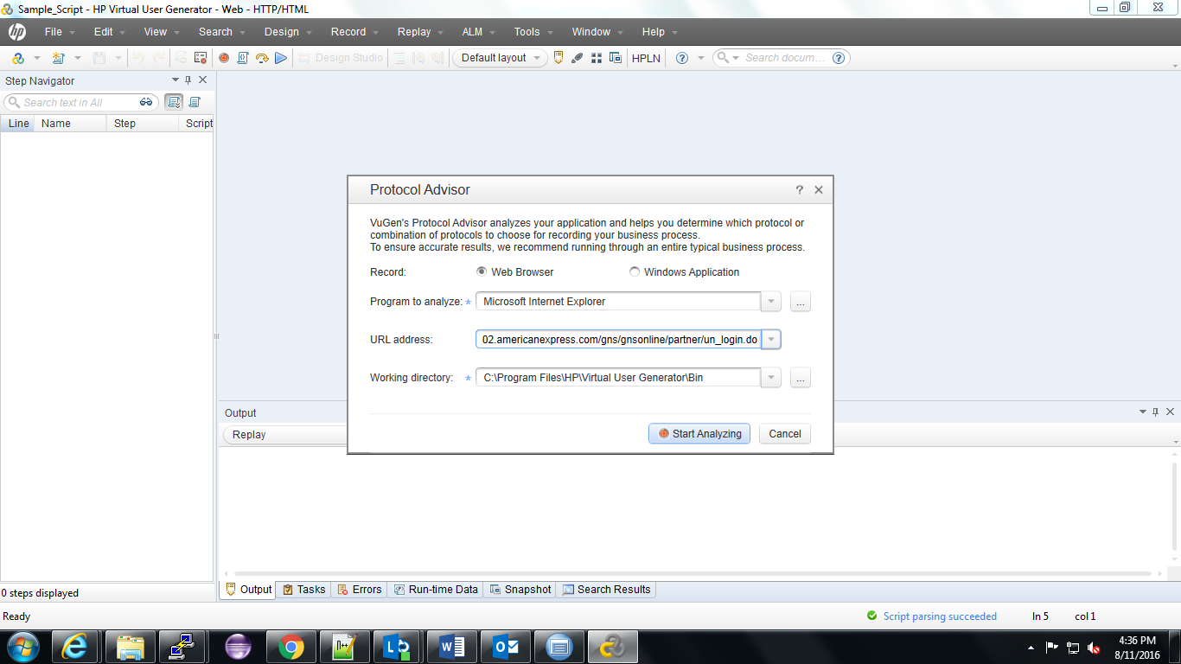

After clicking “Start Analyzing” the application opens in the browser which we given as input and then do some user journey in the application and click on “Finish Analyzing”. Upon clicking Finish the list of supported protocols will be displayed

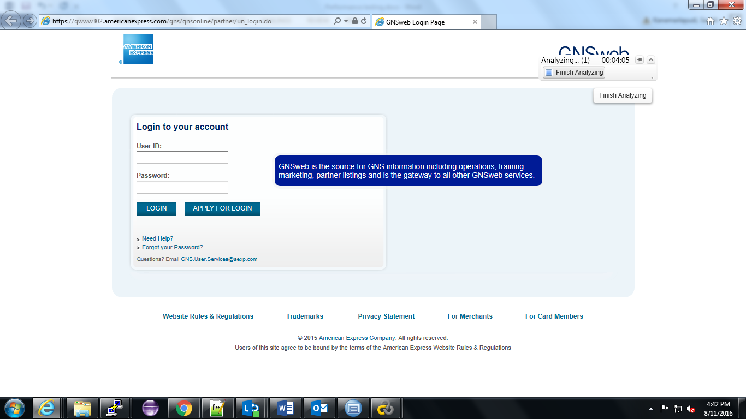

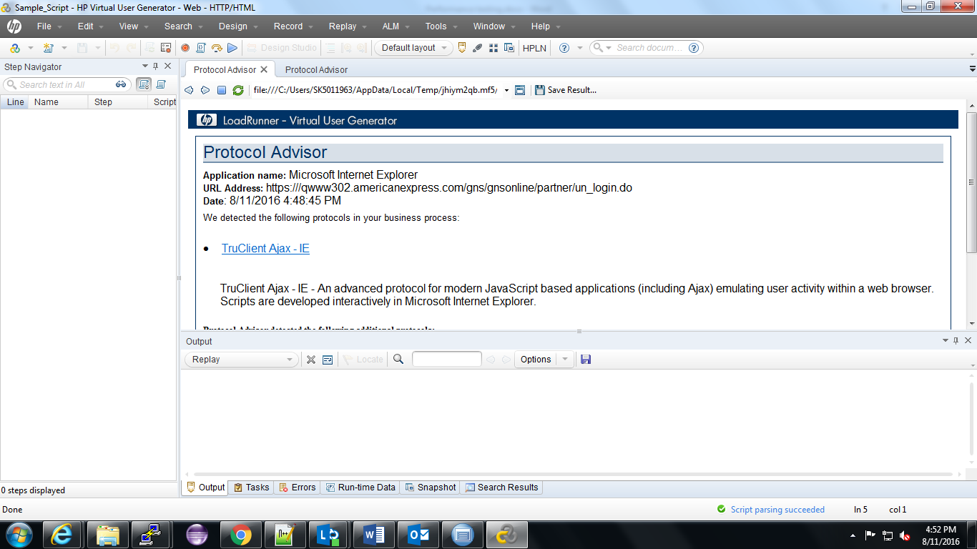

If the user already knows the protocol he can directly start recording the script by pressing **Record** button or **Ctrl + R**

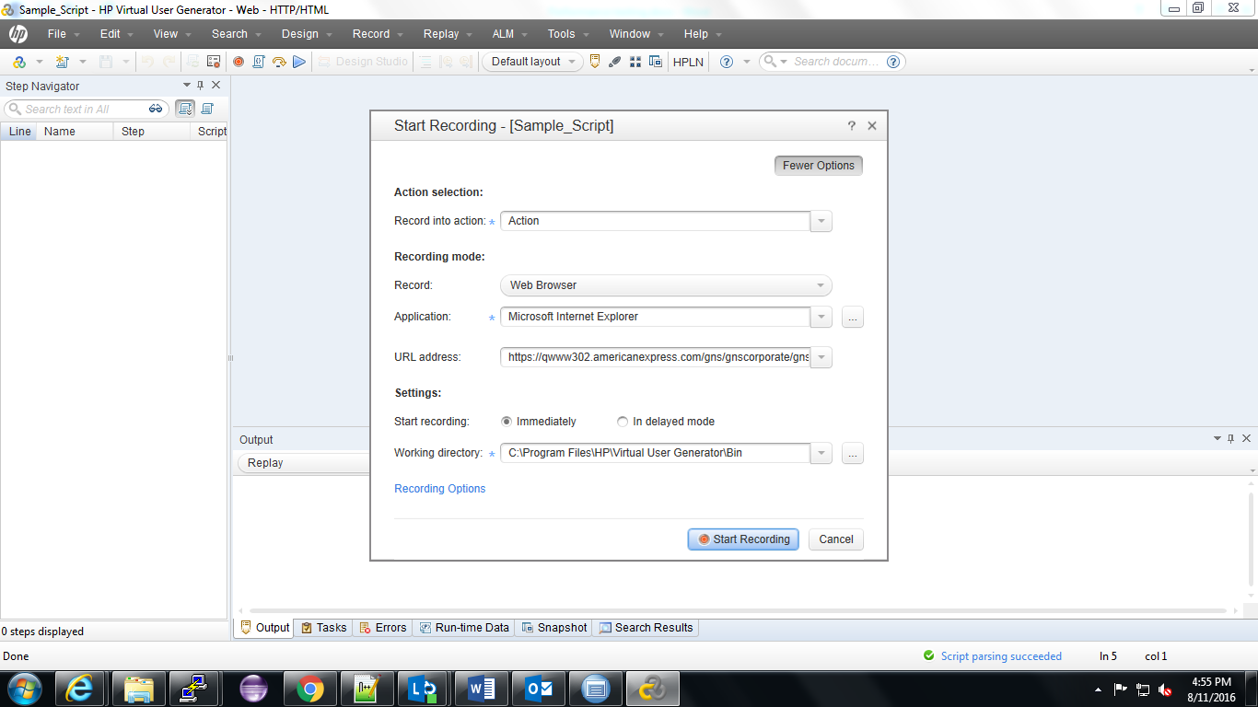

User inputs all the necessary values and clicks “Start Recording” button. Recording of the user journey will be started by triggering the required web browser by the application.

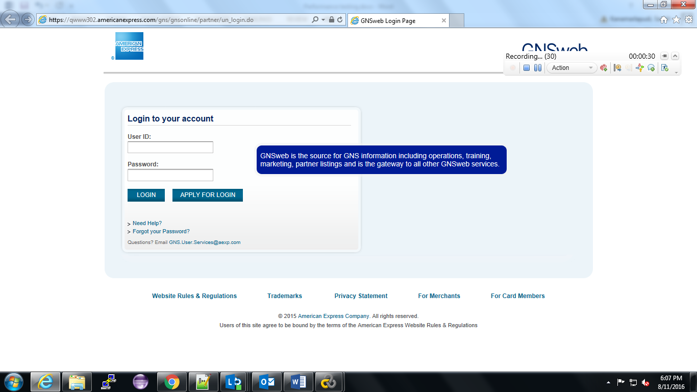

**Mode of Recording**

In **HTTP/HTML** protocol of recoding a script, internally we have 2 more options of creating script. They can be accessed by clicking on the “**Record Options**” button in record menu.

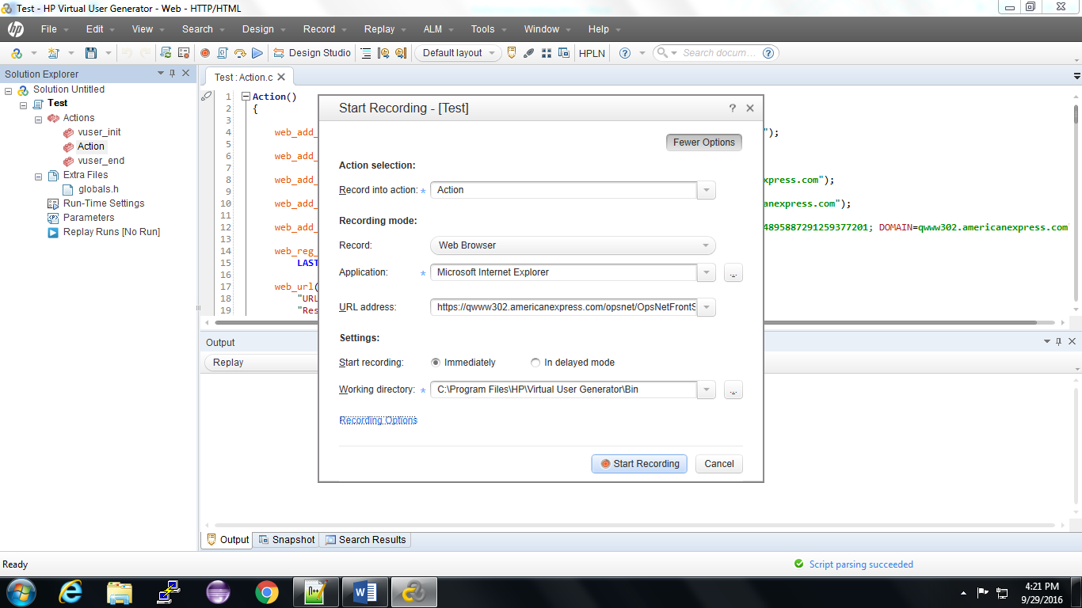

Upon clicking “Recording Options” we will get another pop up in that window under General -- > Recording section select “URL based script” as it captures all the request and responses of all the user actions

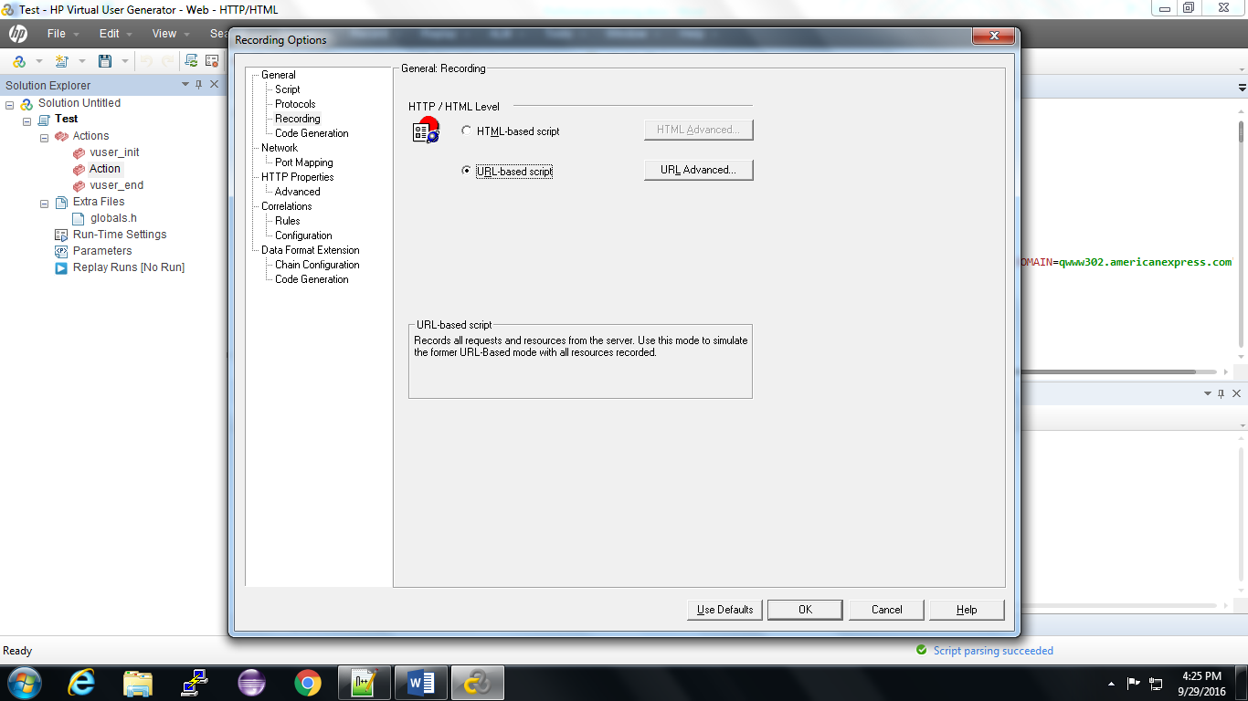

Once the mode got selected click OK button and we will be redirected to “Start Recording” window again and click on Record button to start recording the script.

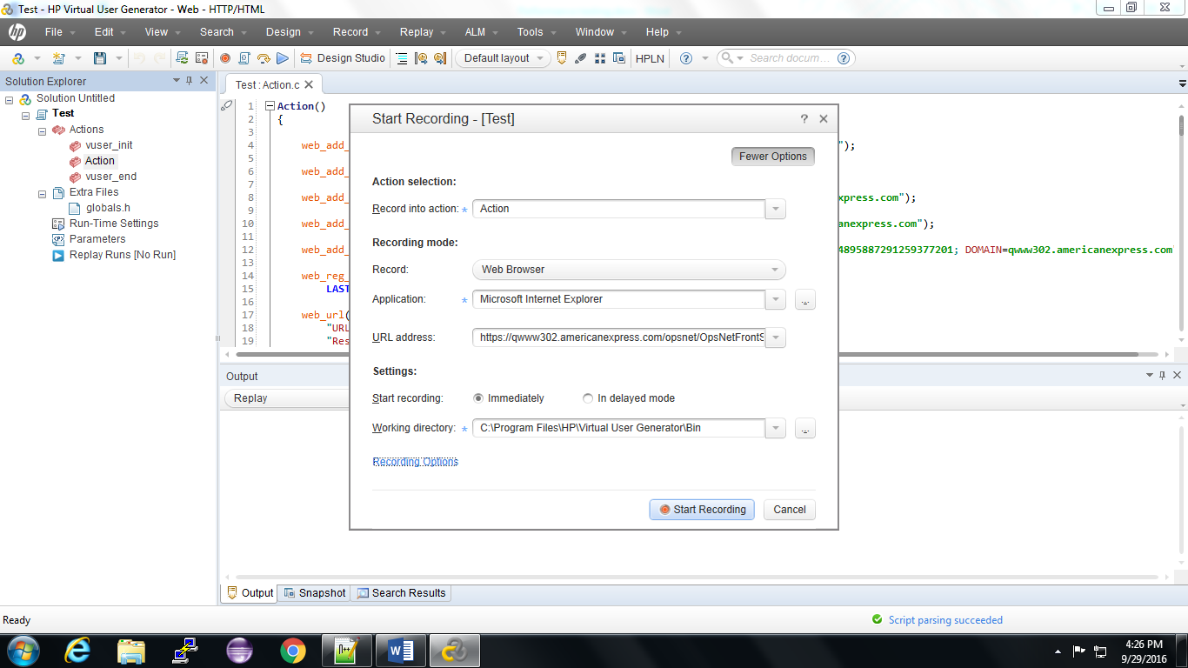

**How to Record a basic script**

Once we selected the Protocol used for creating script, mode of recording and click on start recording script recording will started by launching the browser instance specified in “Start Recording” pop up. Once the recording start the screen looks like below

As highlighted in the above screenshot , the pop up has many buttons which helps to create or end a transaction or pause/stop recording script and says how many events has been recorded as of now.

Transaction indicates the user action that is being created. For example login is a particular action that has to be done by user and whose performance need to be calculated. So we need to a transaction appropriate to measure the response time of login action.

Transaction can be created by clicking on the green clock button. Once we clicked on the clock we need to provide a name and click on ok button. Once we click on it new transaction will be created.

Once we created transaction provide the details and click on Go button. Please not that it is not a good practice to use keyboard enter for button actions.

Once you believe that response is generated well and all the page is created successfully we can end transaction by clicking on the red button.

In this way we have to required user journey script by providing appropriate transaction names and end points.

Once the required user journey is captured in the script, try to replay the script to ensure all the required necessary user actions are covered as expected.

Once the record and replay is perfect and as expected we need fine tune the script for multiple users. As part of fine tuning first step is to remove the cookies in the script. Cookies can be easily found under the line “web_set_cookie” and in the next step remove all the “favicon.ico” requests. This is the initial process of fine tuning the script. Once this is done check whether all the necessary user actions are covered between transaction block. This is needed because if we are not keeping any user action in a transaction we will be able to calculate the response time of that action.

**Next Steps to be followed after fine tuning the script**

Once the script is fine-tuned by removing the cookies and favicon, look out for the input values provided by users that needed to pass for the script to perform the user action. We call this process as parameterization. Parameterizing the script says about how we are passing the input values to script.

Once the required parameterization is done we have to test the script by passing inputs as per the below scenario

* Single user single iteration
* Multiple(usually 2) user single iteration

**Parameterization steps for OpsNet Login**

1. Select the User ID which needs to be parameterized, right-click on the value and click on Replace with Parameter->Create New Parameter

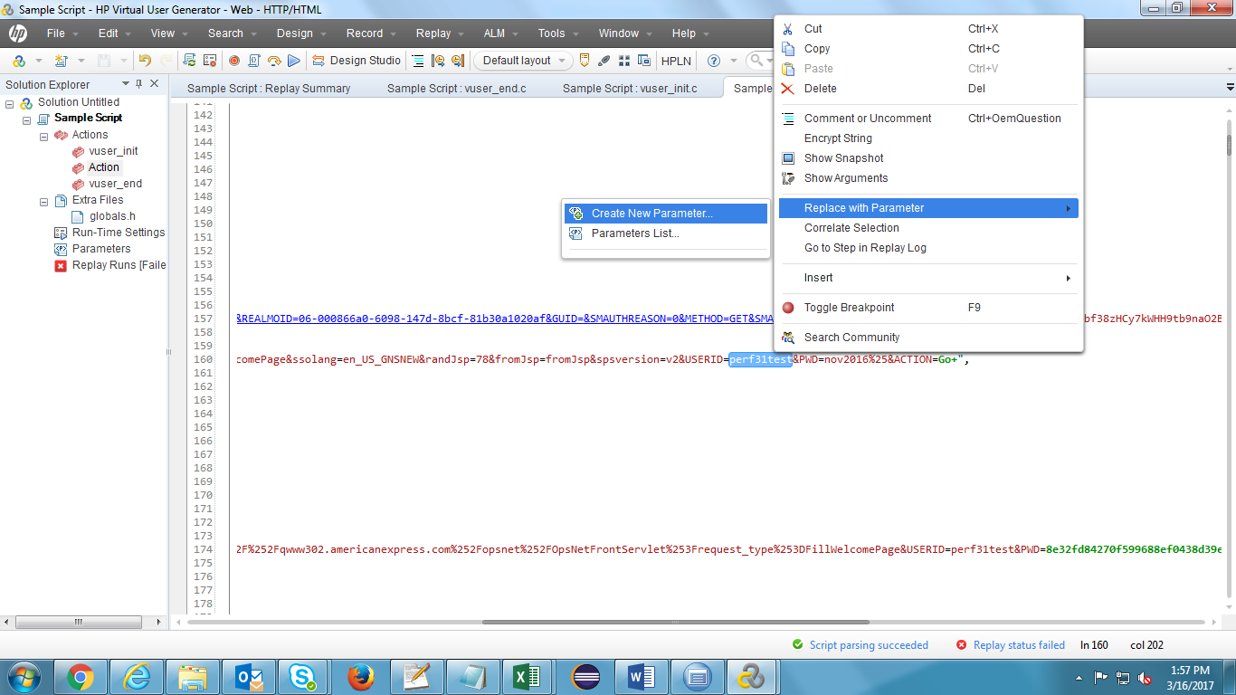

1. Enter a parameter name and click on ‘OK’ button

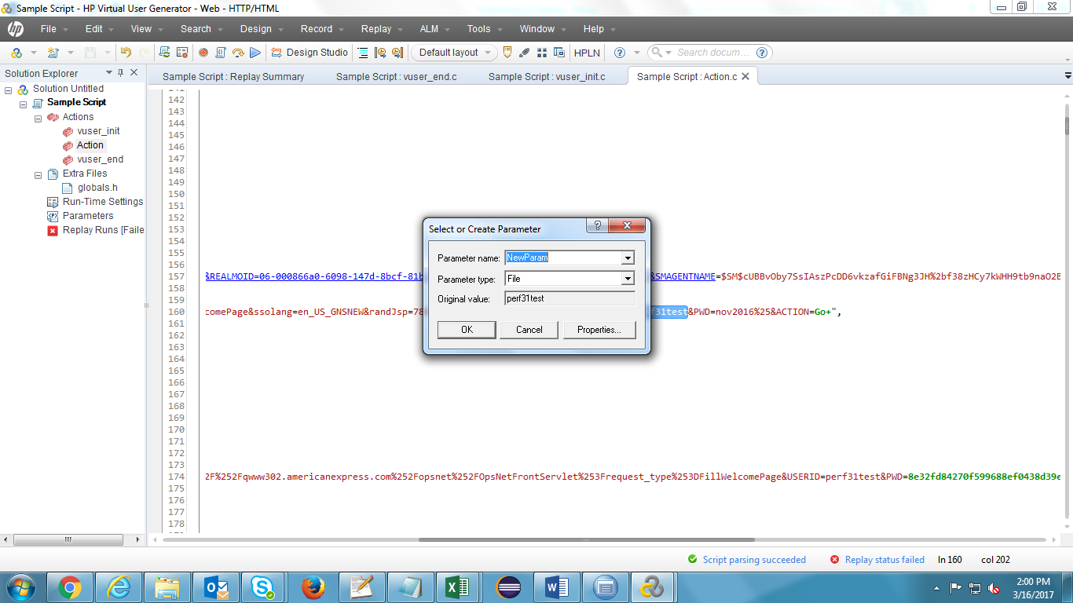

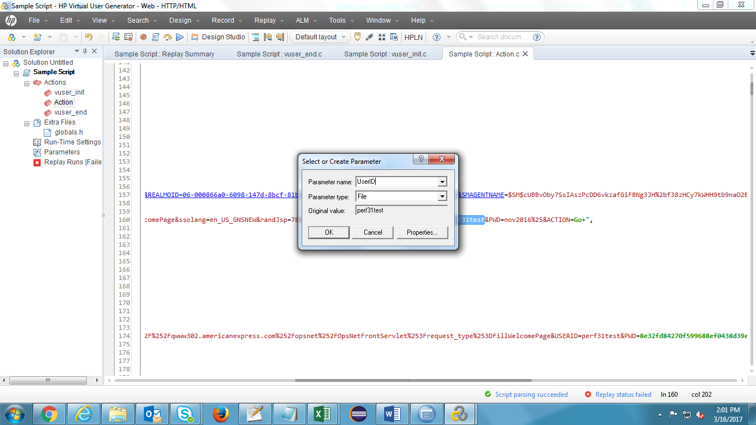

1. Click on ‘Yes’ to replace more occurrences of the string with parameter

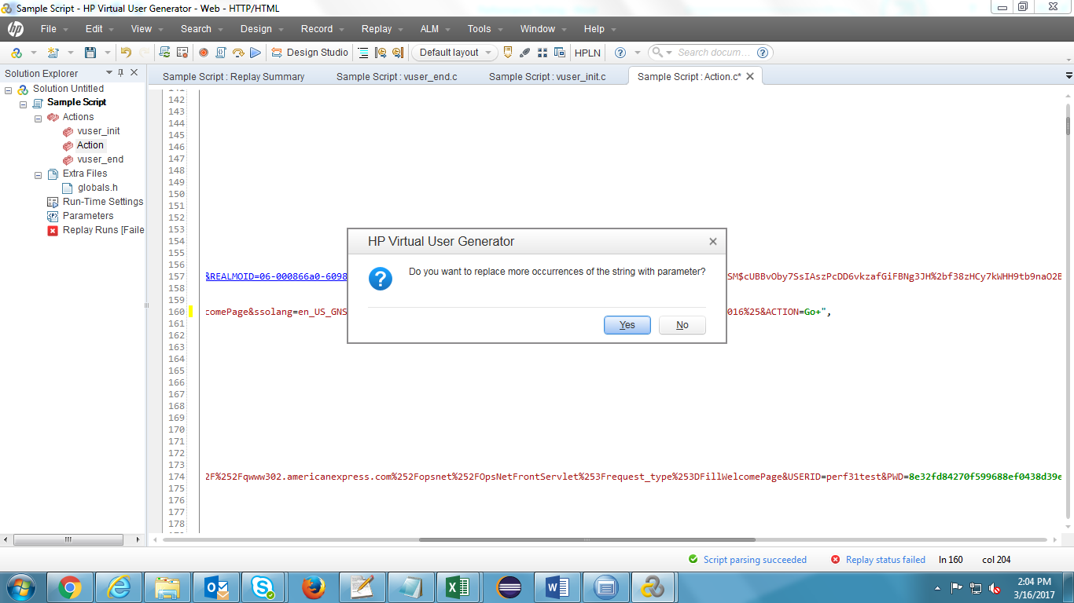

All the occurrences of the string is replaced with the parameter name. Hence, user id value is not found in the script.

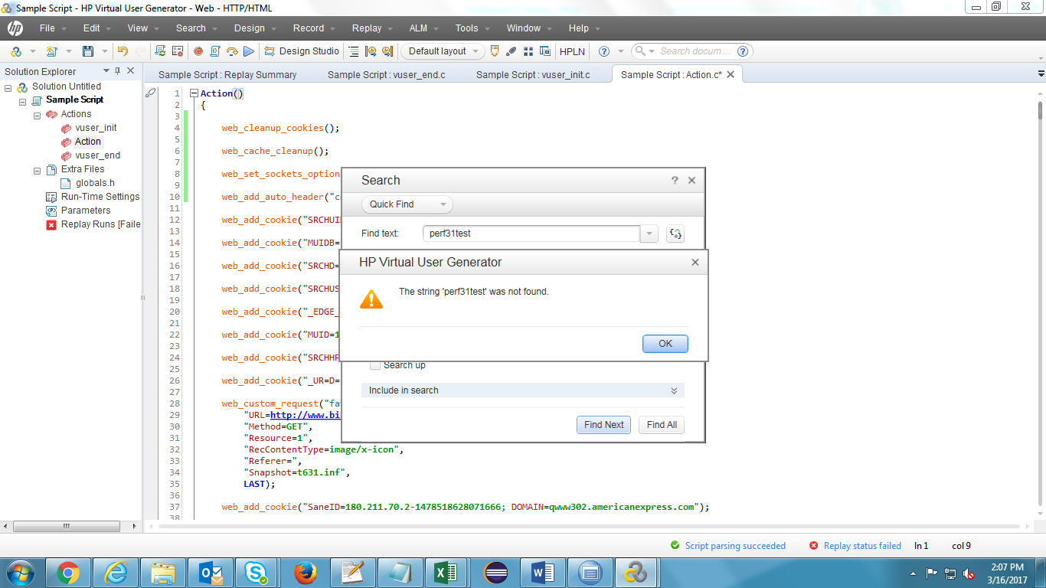

1. Click on Parameters in the Solution Explorer window.

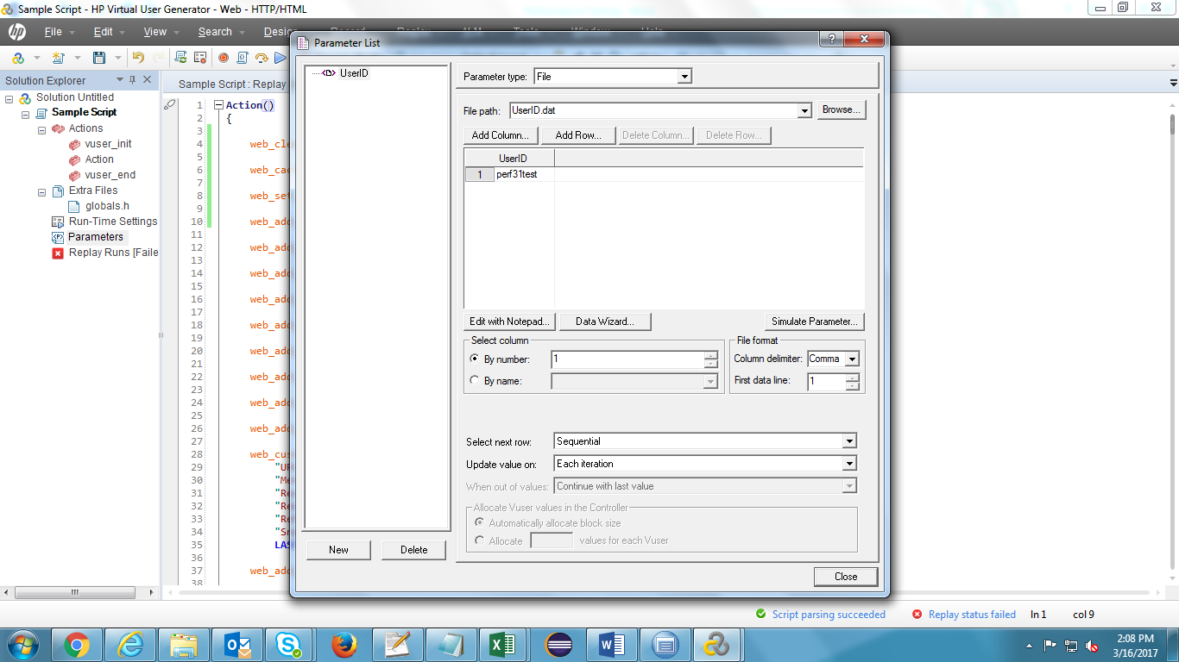

1. Click on ‘Edit with Notepad’ button in the Parameter List wizard.

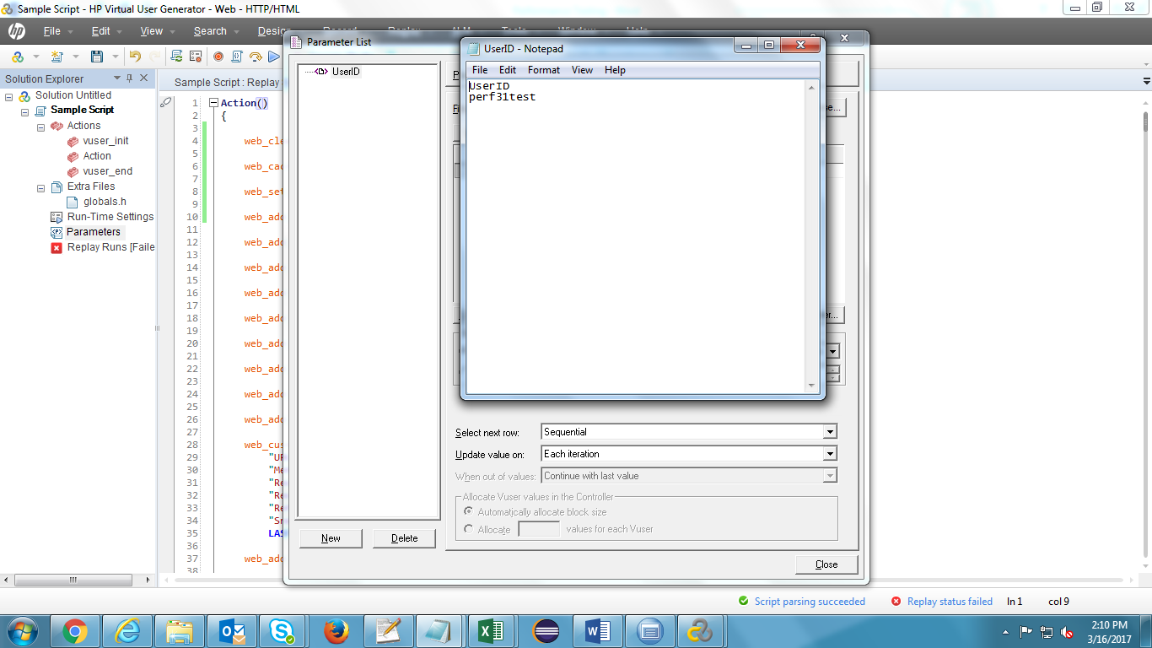

1. Enter the other User ID’s for running the script with multiple users and save the notepad.

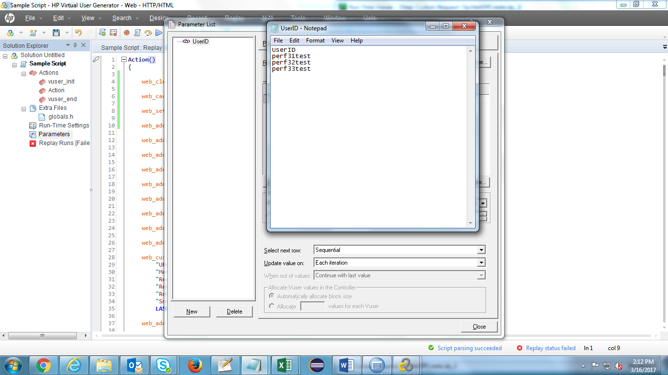

1. User ID’s will be updated in the UserID parameter column

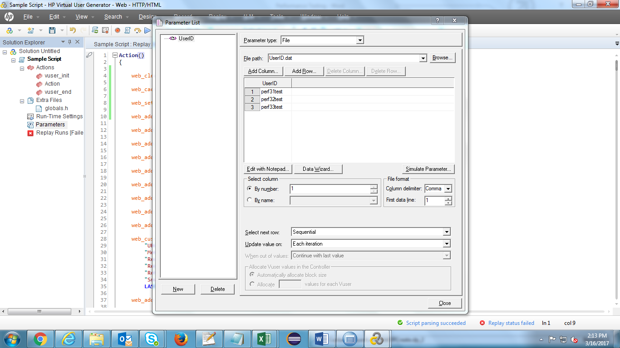

1. Increase the Number of Iterations in Run-Time Settings->Run Logic wizard in order to run the script for multiple users

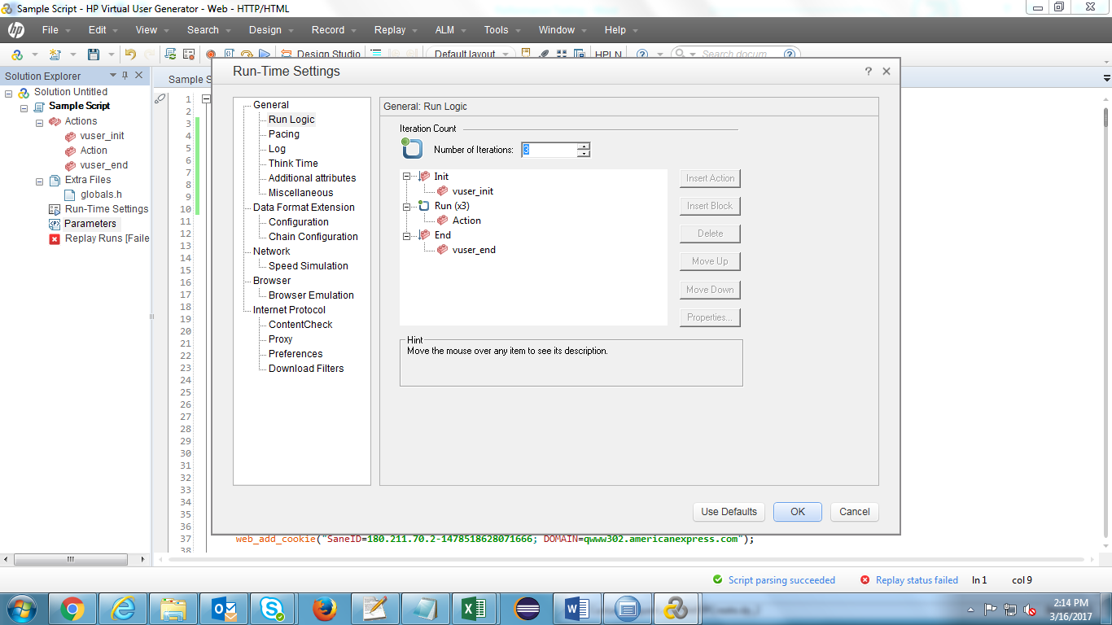

We need to test the script in above scenario to check when dynamic parameters are getting generated in request/response. In that case we need to correlate the particular value in the script. It can be done in 2 ways.

* Manual Correlation
* Automatic Correlation

**Automatic Correlation:** In this scenario, we have to find the particular dynamically generated value and select the value and right click on the value and select correlate the parameter. Once clicking on OK Load Runner will take care of correlating the parameters.

**Manual Correlation:** We can achieve correlation in this scenario by running the script multiple times, we have compare the response for each and every run then find out the dynamic element that is getting generated in the run. Once the dynamic element is generated use the default functions to do correlation

**Steps for performing Correlation in the recorded script**

1. Select the dynamically generated value and right click on the value. Click on ‘Correlate Selection’

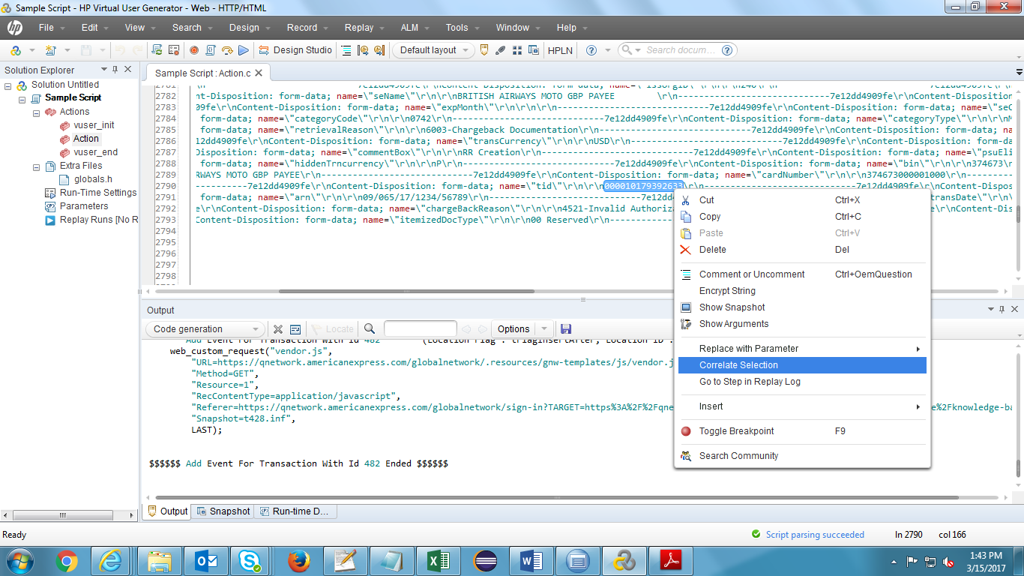

1. Enter parameter prefix name for the Correlation Parameter

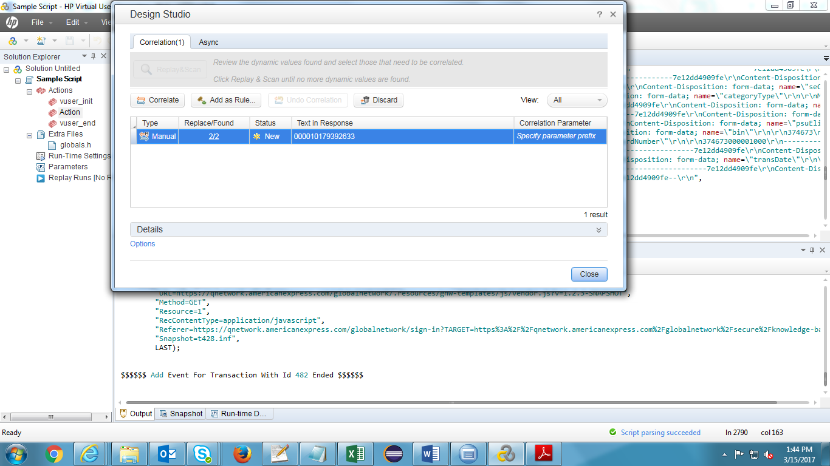

1. Click on ‘Correlate’ button

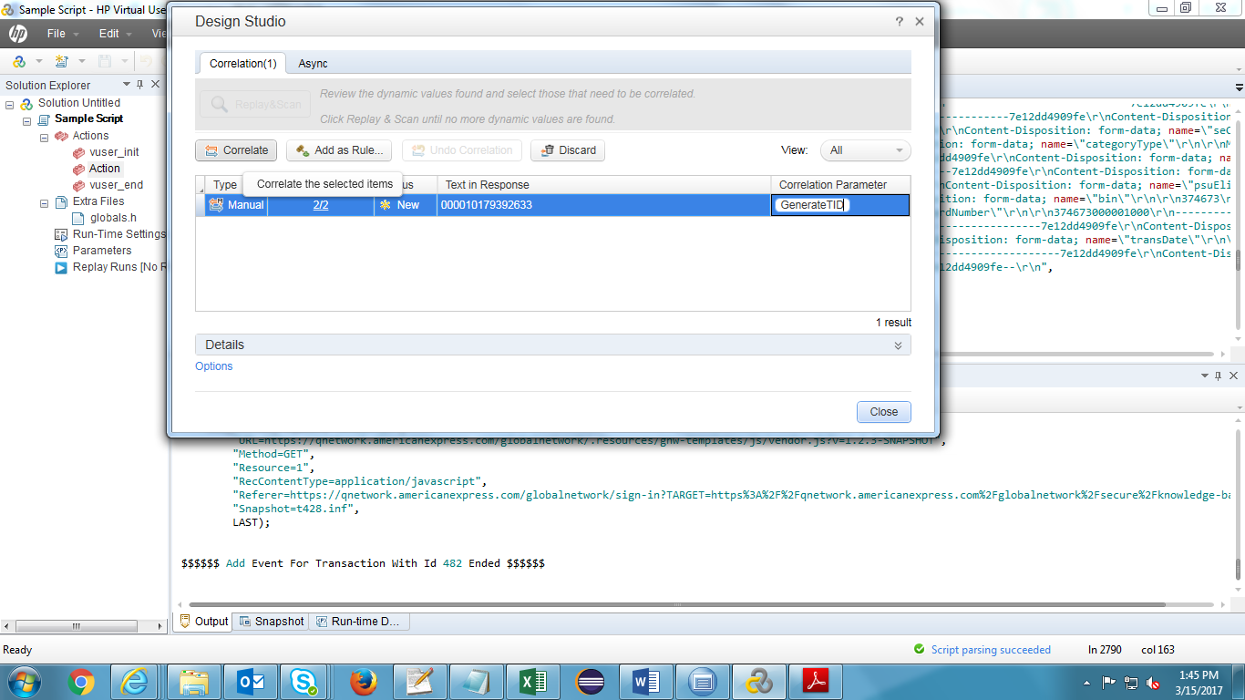

1. Correlation is applied successfully for the dynamically generated value

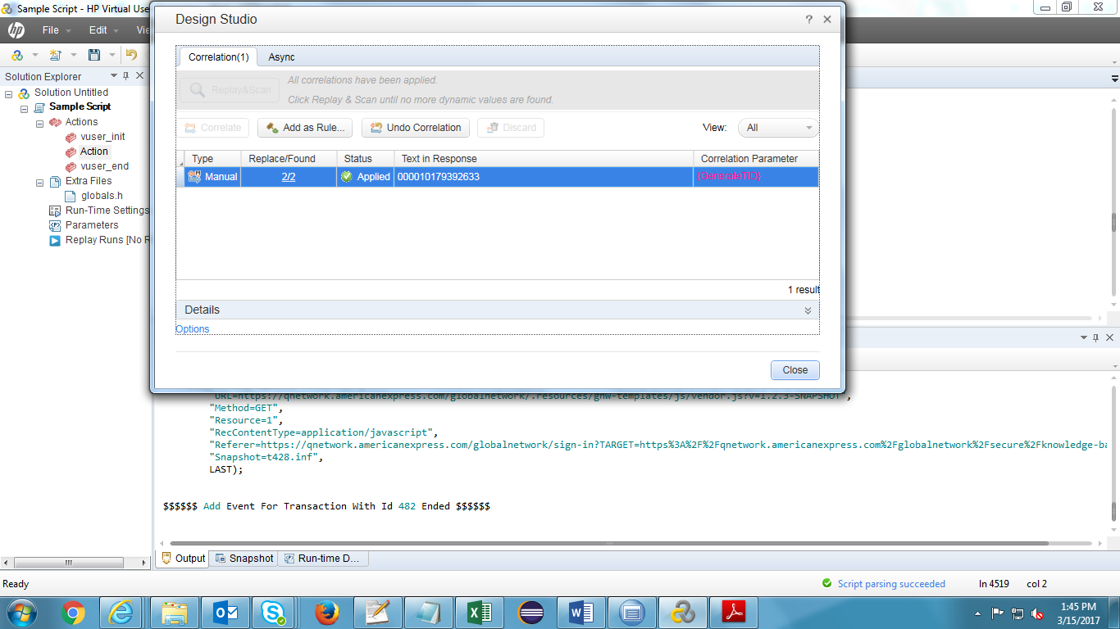

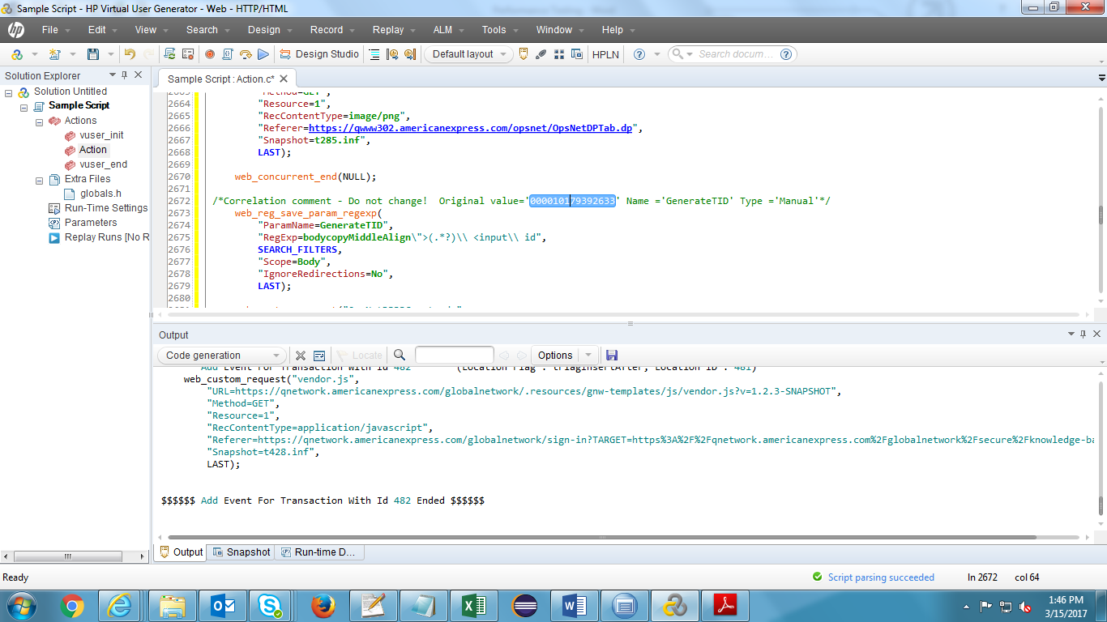

1. Original value will be replaced by the correlation parameter name wherever found

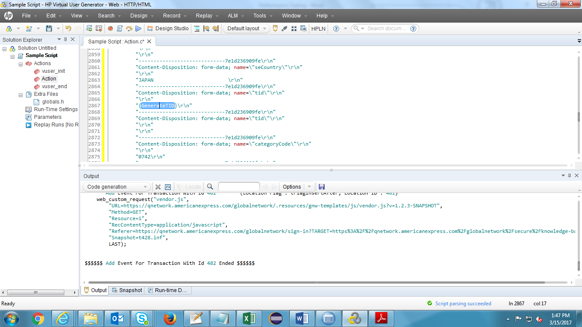

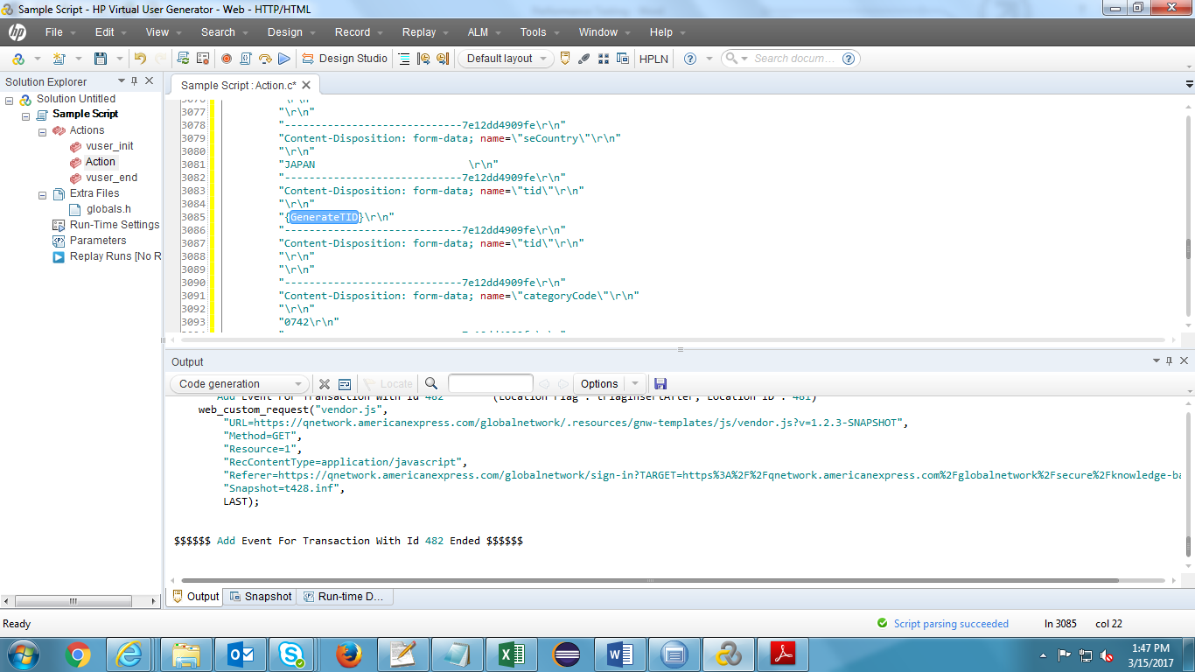

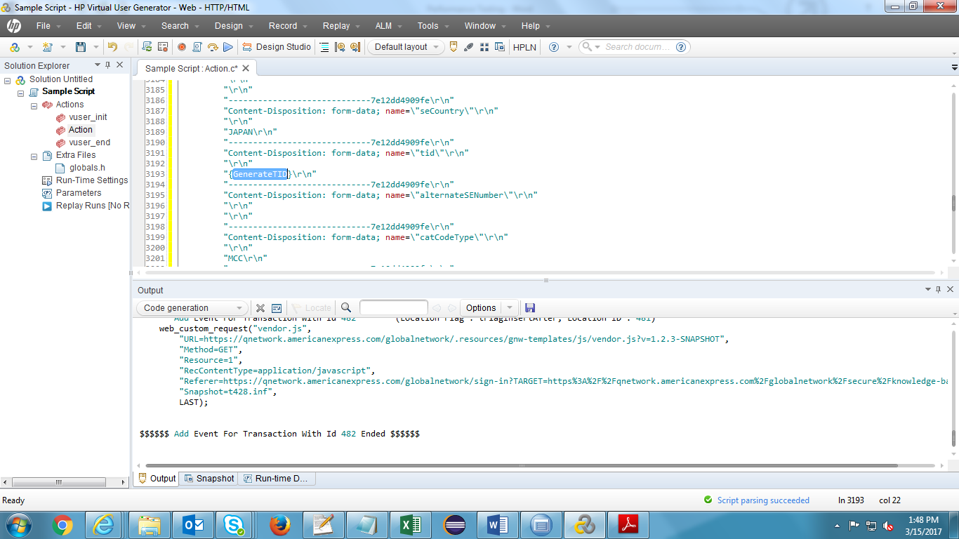

**Run Time and proxy Settings :**

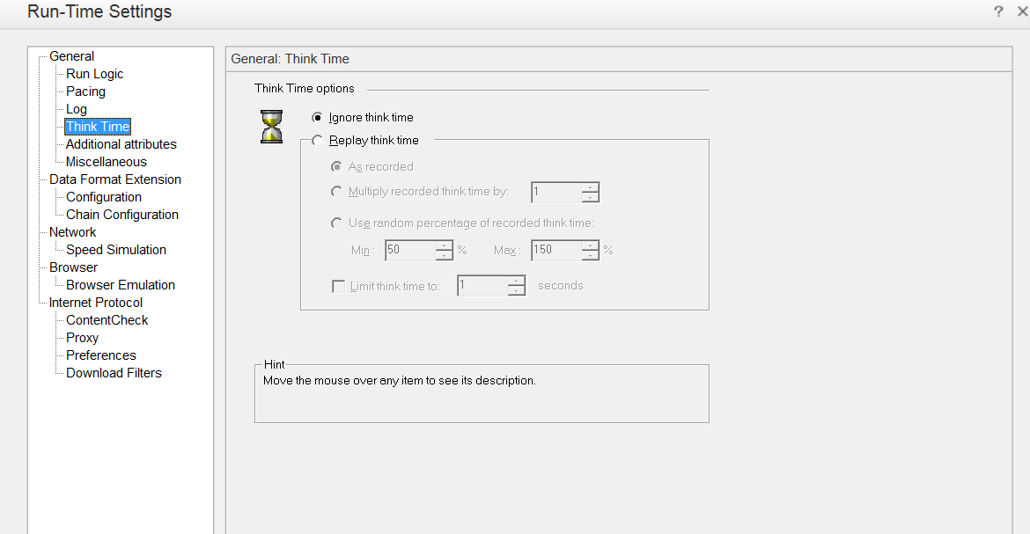

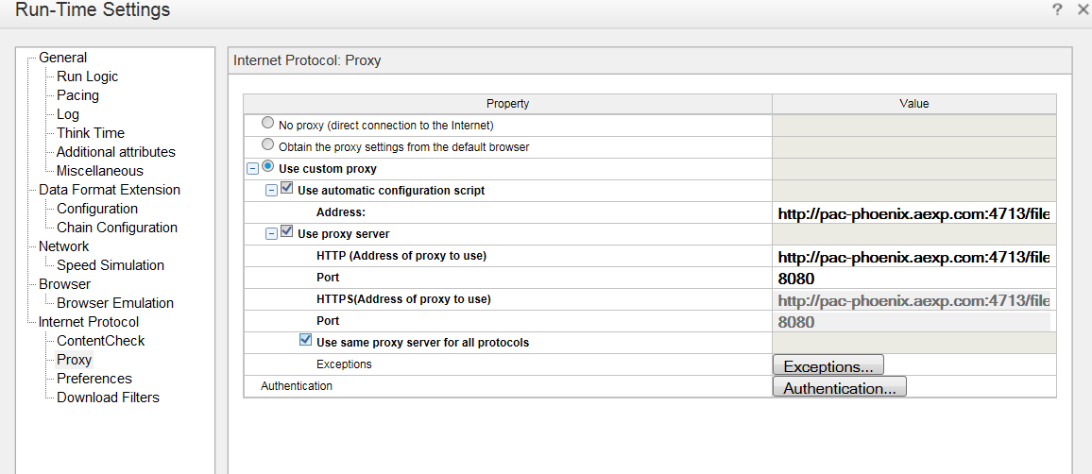

**Click on Authentication button and Enter the ADS credentials in authentication option**

**Goto preferences and click on option**

**Increase step download timeout**

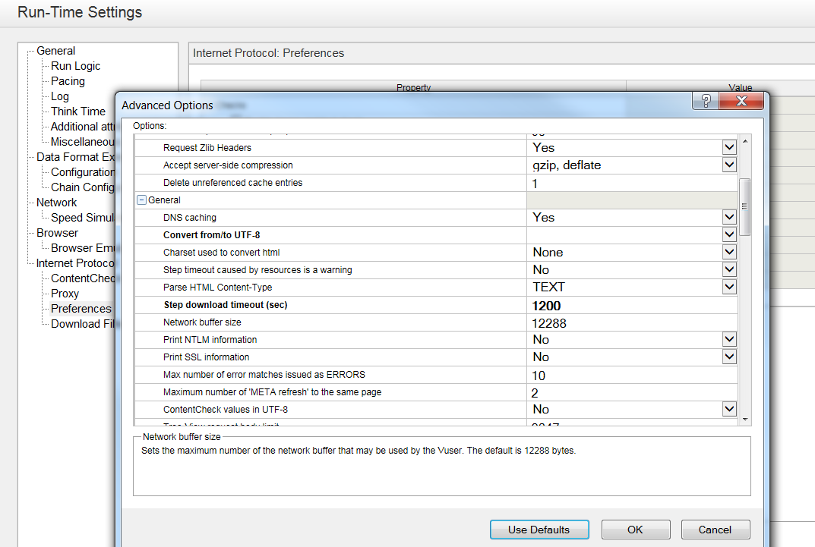

**Uploading performance scripts to Quality Center**

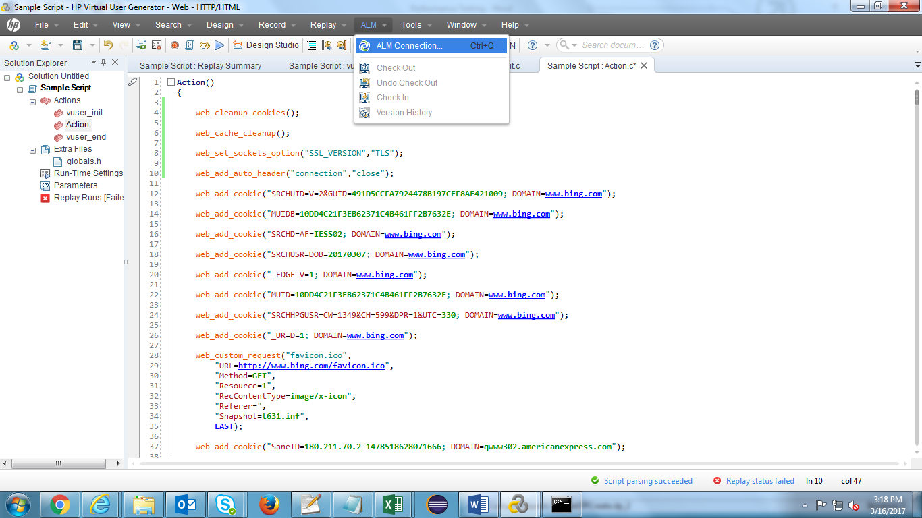

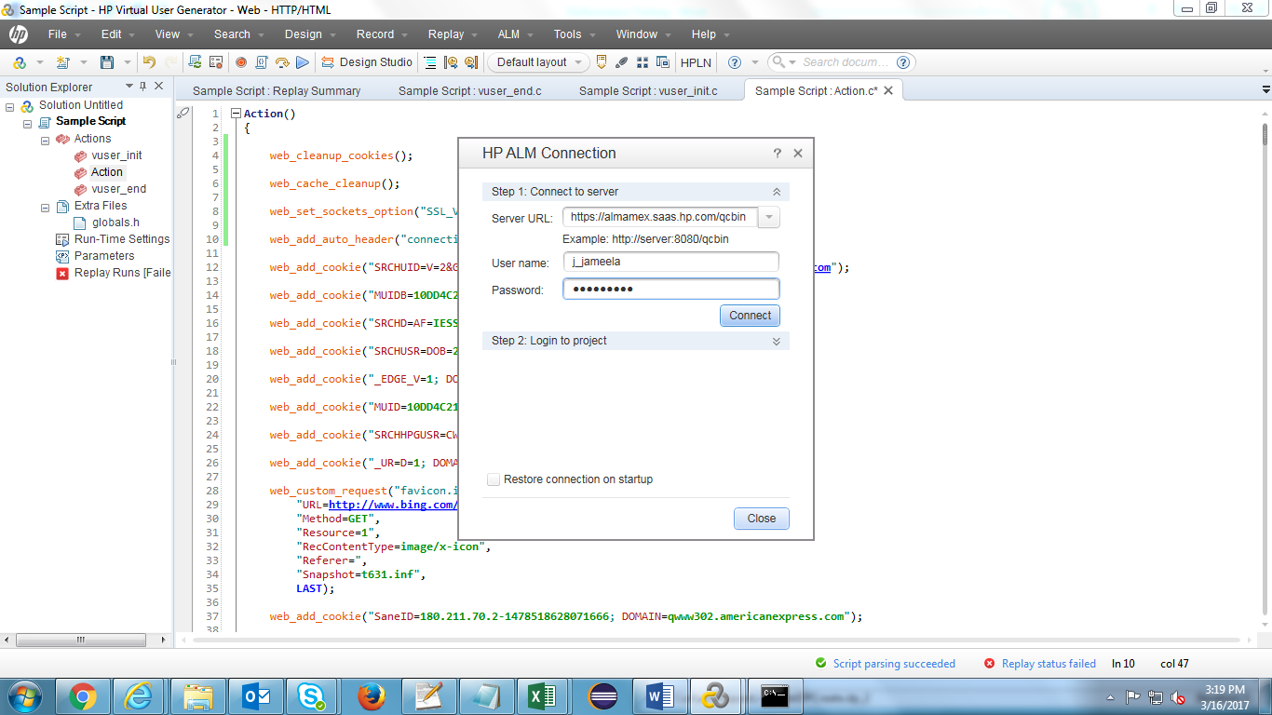

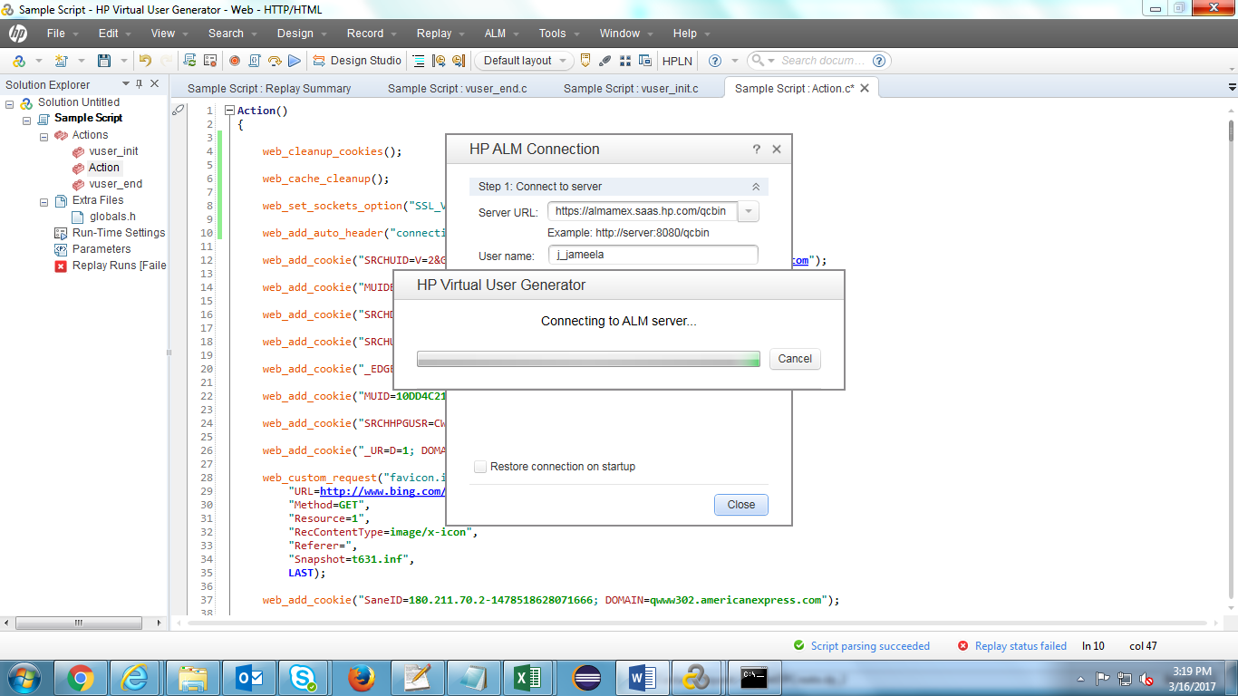

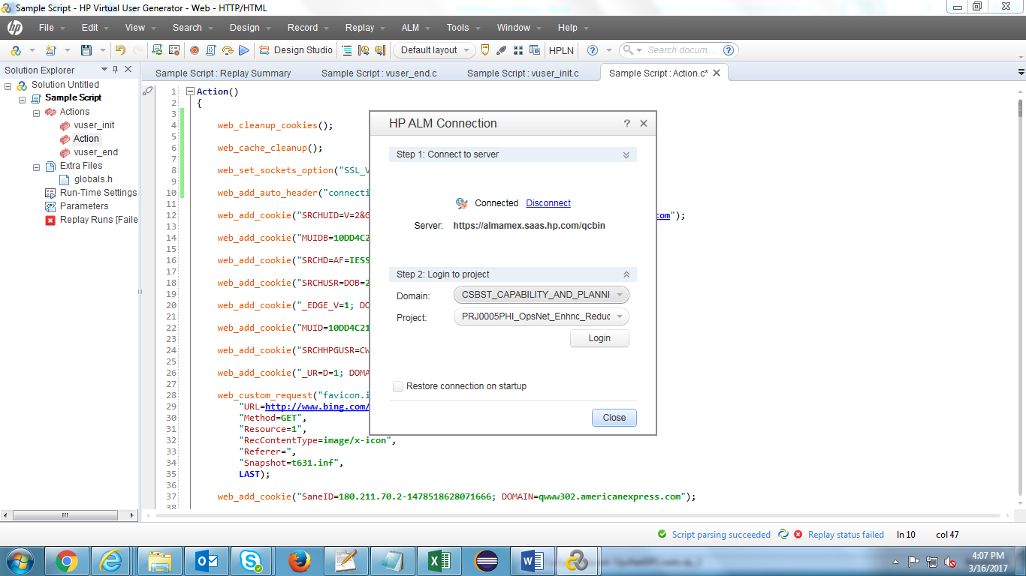

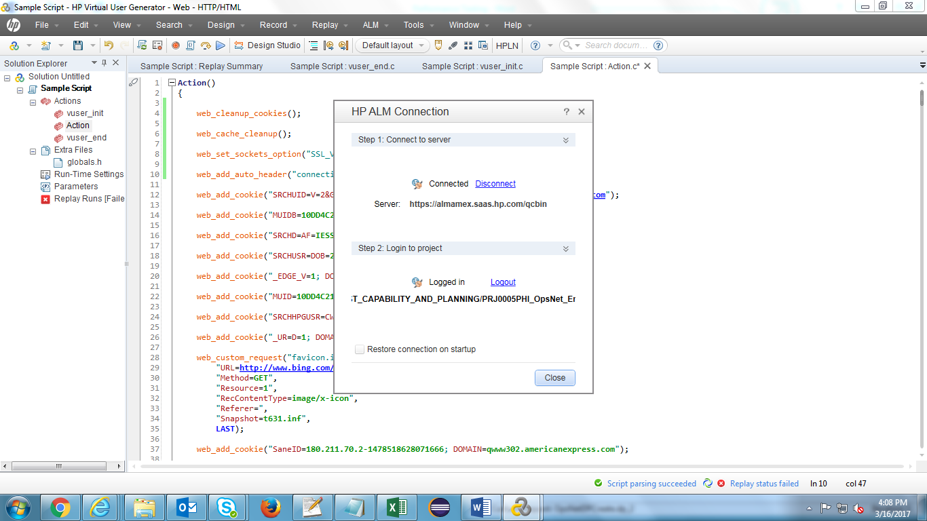

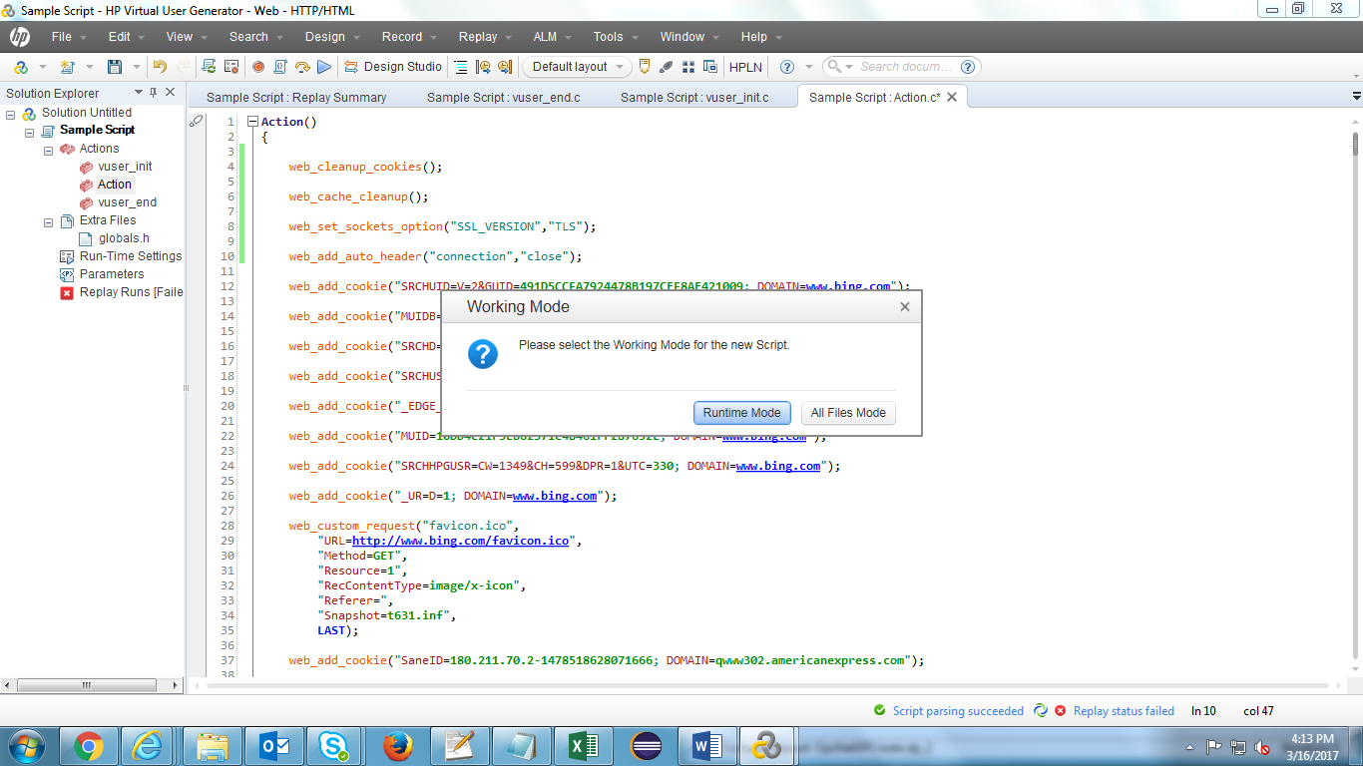

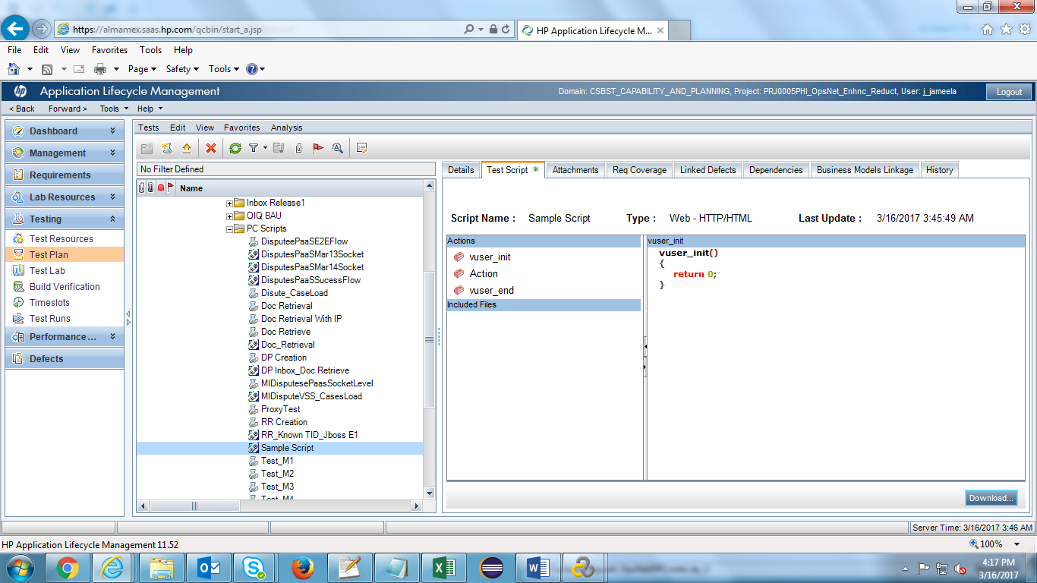

Note : Please add the below functions to the action script in the first line if you are facing Protocol error during reply or execution

web_set_sockets_option("SSL_VERSION","TLS1.1");  
  
    web_add_auto_header("connection","close");  
      
    web_set_sockets_option("MAX_CONNECTIONS_PER_HOST","1");